1) Create a JSP application which gets basic price of five products from user along

with GST rate in % through welcome.html. Display invoice amount with base price

of all products and the tax payable amount on invoice.jsp page. If user enters any

value except in numeric then display error.jsp page with an error message “Enter

Price and Rate in Numeric format” and generated exception message.

welcome.html

<html>

<head>

<title>Online Store</title>

</head>

<body>

<pre>

<hr><h1>ONLINE STORE</h1><hr>

<form method="POST" action="invoice.jsp">

<table border=1>

<tr>

<td>Enter Name</td>

<td><input type="text" name="nm"></td>

</tr>

<tr>

<td>Product List</td>

<td>Gst Rate</td>

<td>Price</td>

<td>Product Quantity</td>

</tr>

<tr>

<td>AC</td><td> <input type="text" name="acr" ></td>

<td><input type="text" name="aprice" value="55000" ></td>

<td><input type="text" name="aqan"></td>

</tr>

<tr>

<td>Tv</td><td> <input type="text" name="tvr" ></td>

<td><input type="text" name="tprice" value="36000" ></td>

<td><input type="text" name="tqan"></td>

</tr>

<tr>

<td>IPHONE</td><td> <input type="text" name="ipr"></td>

<td><input type="text" name="iprice" value="75000" ></td>

<td><input type="text" name="iqan"></td>

</tr>

<tr>

<td>Leptop</td><td> <input type="text" name="ler"></td>

<td><input type="text" name="lprice" value="75000" ></td>

<td><input type="text" name="lqan"></td>

</tr>

<tr>

<td>Washing Manchine</td><td> <input type="text" name="wmr"></td>

<td><input type="text" name="wmprice" value="75000" ></td>

<td><input type="text" name="wmqan"></td>

</tr>

</table>

<input type="submit" name="submit" value="Buy Now">

</form>

</pre>

</body>

</html>

invoice.jsp

<html>

<body>

<%@ page errorPage="error.jsp"%>

<%

String nm1 = request.getParameter("nm");

String i1Name="Ac";

float i1rate = Float.parseFloat( request.getParameter("acr"));

int i1price = Integer.parseInt(request.getParameter("aprice"));

int i1quan = Integer.parseInt(request.getParameter("aqan"));

float i1pay = (i1price * i1quan);

float i1tot = i1pay +((i1pay * i1rate)/100);

String i2Name="TV";

float i2rate = Float.parseFloat( request.getParameter("tvr"));

int i2price = Integer.parseInt(request.getParameter("tprice"));

int i2quan = Integer.parseInt(request.getParameter("tqan"));

float i2pay = (i2price * i2quan);

float i2tot = i2pay +((i2pay * i2rate)/100);

String i3Name="IPHONE";

float i3rate = Float.parseFloat( request.getParameter("ipr"));

int i3price = Integer.parseInt(request.getParameter("iprice"));

int i3quan = Integer.parseInt(request.getParameter("iqan"));

float i3pay = (i3price * i3quan);

float i3tot = i3pay +((i3pay * i3rate)/100);

String i4Name="Leptop";

float i4rate = Float.parseFloat( request.getParameter("ler"));

int i4price = Integer.parseInt(request.getParameter("lprice"));

int i4quan = Integer.parseInt(request.getParameter("lqan"));

float i4pay = (i4price * i4quan);

float i4tot = i4pay +((i4pay * i4rate)/100);

String i5Name="Washing Manchine";

float i5rate = Float.parseFloat( request.getParameter("wmr"));

int i5price = Integer.parseInt(request.getParameter("wmprice"));

int i5quan = Integer.parseInt(request.getParameter("wmqan"));

float i5pay = (i5price * i5quan);

float i5tot = i5pay +((i5pay * i5rate)/100);

float totpay = i1tot+i2tot+i3tot+i4tot+i5tot;

%>

<center>

Customber Name is <%out.print(nm1);%>

<table border="1">

<tr>

<td>Item Name</td>

<td>Item Price</td>

<td>Item Quantity</td>

<td>Item Pay</td>

</tr>

<tr>

<td><%out.print(i1Name);%></td>

<td><%out.print(i1price);%></td>

<td><%out.print(i1quan);%></td>

<td><%out.print(i1tot);%></td>

</tr>

<tr>

<td><%out.print(i2Name);%></td>

<td><%out.print(i2price);%></td>

<td><%out.print(i2quan);%></td>

<td><%out.print(i2tot);%></td>

</tr>

<tr>

<td><%out.print(i3Name);%></td>

<td><%out.print(i3price);%></td>

<td><%out.print(i3quan);%></td>

<td><%out.print(i3tot);%></td>

</tr>

<tr>

<td><%out.print(i4Name);%></td>

<td><%out.print(i4price);%></td>

<td><%out.print(i4quan);%></td>

<td><%out.print(i4tot);%></td>

</tr>

<tr>

<td><%out.print(i5Name);%></td>

<td><%out.print(i5price);%></td>

<td><%out.print(i5quan);%></td>

<td><%out.print(i5tot);%></td>

</tr>

<tr>

<td></td>

<td>Total Pay</td>

<td></td>

<td><%out.print(totpay);%></td>

</tr>

</table>

</center>

</body>

</html>

error.jsp

<%@ page isErrorPage="true" %>

Exception is : <% out.print("Enter Price and Rate in Numeric format"); %>

Output:-

1) With error Page

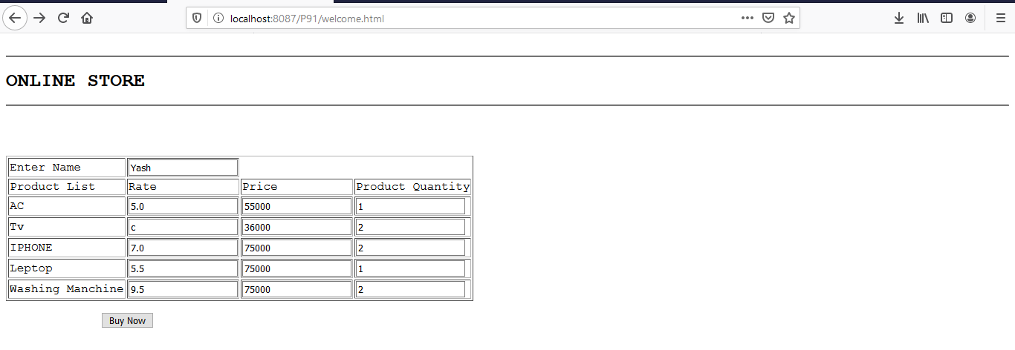

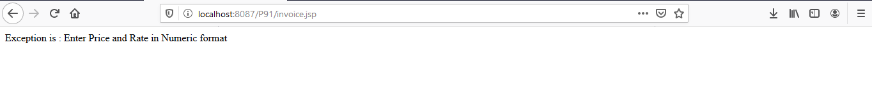

2) Without error

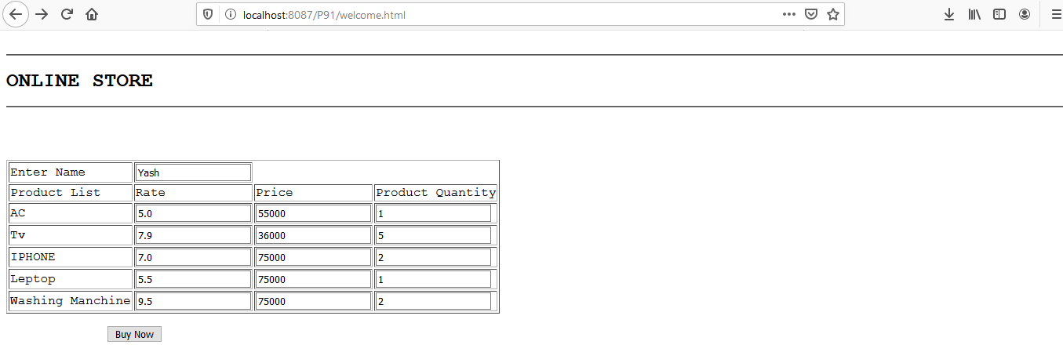

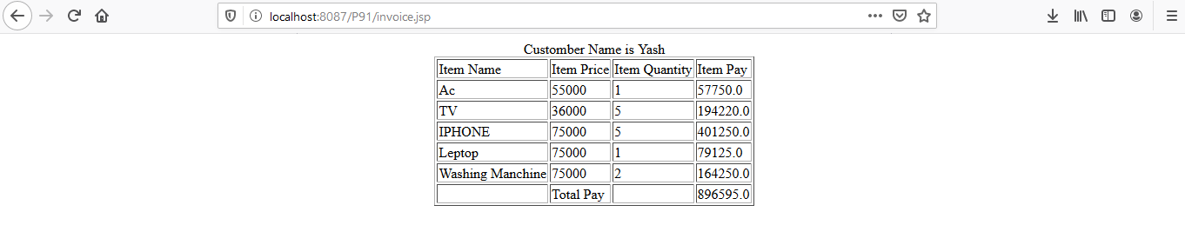

2) Create a JavaBean named ProductBean to hold productNo(int), description(String),

price(float) and quantity(int). Create HTML page that requests user for input. On

submission a JSP page should be executed to store data in productBean instance

and read the data and display in appropriate format.

index.html

<html>

<head>

<title>JAVA</title>

</head>

<body>

<pre>

<form action="product.jsp" method="post">

Product Name : <input type="text" name="pname">

Description : <input type="text" name="desc">

price : <input type="text" name="price">

Quantity : <input type="text" name="qun">

<input type="submit" name="submit">

</form>

</pre>

</body>

</html>

product.java

package com.newfolder;

public class product implements java.io.Serializable {

private String pname = null;

private String price = null;

private String qun = null;

private String desc = null;

public product() {

}

public String getpname(){

return pname;

}

public String getprice(){

return price;

}

public String getqun(){

return qun;

}

public String getdesc(){

return desc;

}

public void setpname(String pname){

this.pname = pname;

}

public void getprice(String price){

this.price = price;

}

public void getqun(String qun){

this.qun = qun;

}

public void getdesc(String desc){

this.desc = desc;

}

}

product.jsp

<jsp:useBean id="userinfo" class="com.newfolder.product"/>

<jsp:setProperty property="*" name="userinfo"/>

You have enterted below details:<br>

<jsp:getProperty property="pname" name="userinfo"/><br>

<jsp:getProperty property="pprice" name="userinfo"/><br>

<jsp:getProperty property="qun" name="userinfo" /><br>

<jsp:getProperty property="desc" name="userinfo" /><br>

O/P:-

1)index.html

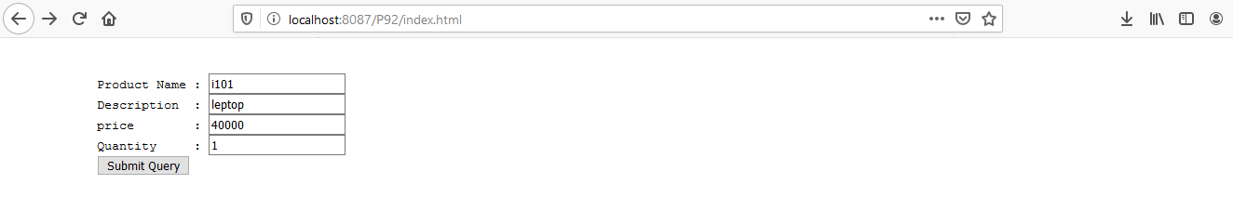

2)product.jsp

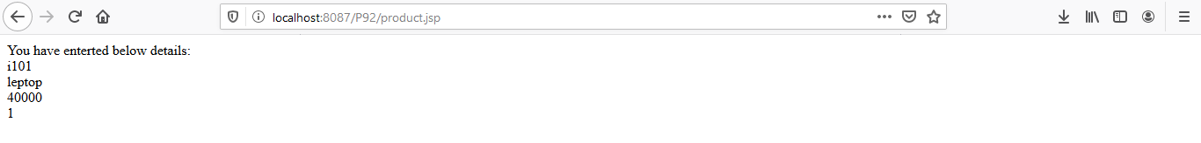

3) Create a jsp application get principle amount ,number of months and rate of interest through index.html .Display the interest amount and total amount in result.jsp page. If the user enters values in except in numeric then display error.jsp page with error message “incorrect values”.

index.html

<html>

<head>

<title>Online Store</title>

</head>

<body>

<pre>

<center>

<hr><h1>Intrest Detail</h1><hr>

<form method="POST" action="result.jsp">

<table border=1>

<tr>

<td>Enter the Amount</td>

<td><input type="text" name="amt"></td>

</tr>

<tr>

<tr>

<td>Enter the Rate</td>

<td><input type="text" name="rate"></td>

</tr>

<tr>

<td> Total Number of months</td>

<td><input type="text" name="mon"></td>

</tr>

</table>

<input type="submit" name="submit" value="Calculate">

</form>

</pre>

</body>

</html>

result.jsp

<html>

<body>

<%@ page errorPage="error.jsp"%>

<%

int amt = Integer.parseInt(request.getParameter("amt"));

int n = Integer.parseInt(request.getParameter("mon"));

float ra = Float.parseFloat( request.getParameter("rate"));

float pay = (amt*n*ra)/1200;

float pay1 = amt + pay;

%>

<center>

<table border="1">

<tr>

<td>Amount</td>

<td><%out.print(amt);%></td>

</tr>

<tr>

<td>Interest</td>

<td><%out.print(pay);%></td>

</tr>

<tr>

<td>Total Pay</td>

<td><%out.print(pay1);%></td>

</tr>

</table>

</center>

error.jsp

<%@ page isErrorPage="true" %>

Exception is : <% out.print("Incorect Values"); %>

O/P:-

1) inedex.html(Without error)

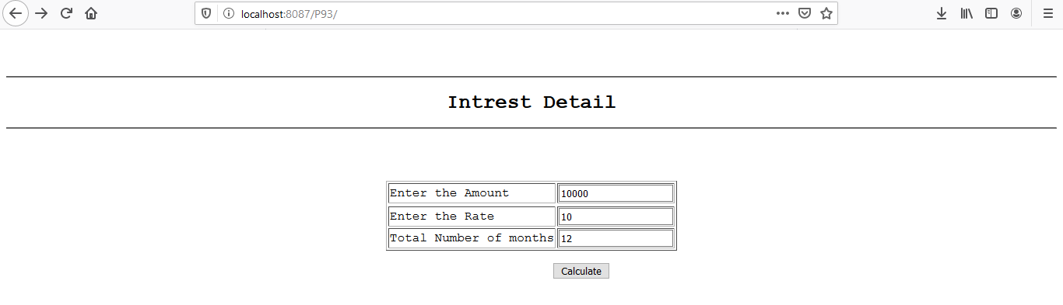

2) resut.jsp

 3) index.html(With error):-

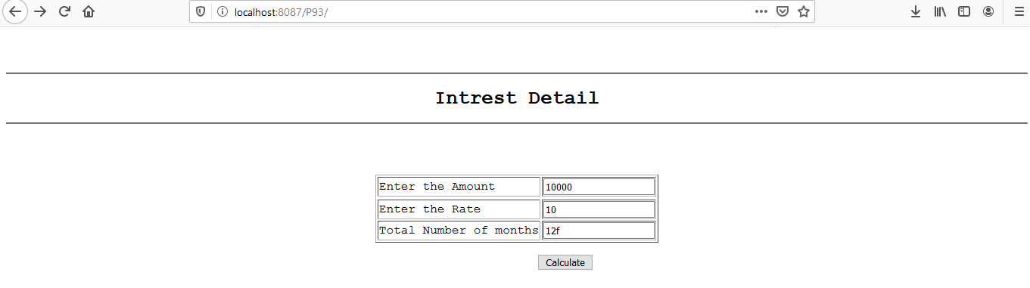

4) result.jsp(Error Page):-

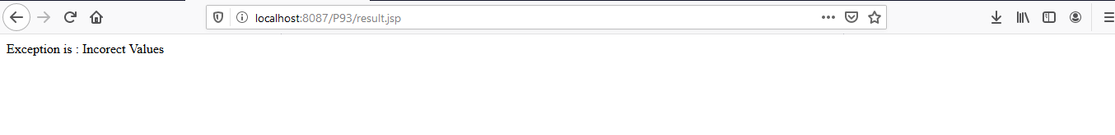

4) Write a jsp page application to accept the username and password from the user and compare with the data stored in deployment descriptor to validate . Using <jsp:forward> action navigates user to welcome page if user is an authorized user and display separate error page if not authenticate user.

Index.html

<html>

<body>

<center>

<form action="wel">

Uname:<input type="text" name="uname"><br>

Password:<input type="password" name="pass"><br>

<input type="submit" value="Config">

<br/>

</form>

</body>

</html>

Web.xml

<?xml version="1.0" encoding="ISO-8859-1"?>

<web-app xmlns="http://java.sun.com/xml/ns/javaee"

xmlns:xsi="http://www.w3.org/2001/XMLSchema-instance"

xsi:schemaLocation="http://java.sun.com/xml/ns/javaee http://java.sun.com/xml/ns/javaee/web-app_2_5.xsd"

version="2.5">

<servlet>

<servlet-name>JSPServlet1</servlet-name>

<jsp-file>/wel.jsp</jsp-file>

<init-param>

<param-name>unam</param-name>

<param-value>admin</param-value>

</init-param>

<init-param>

<param-name>pass</param-name>

<param-value>admin</param-value>

</init-param>

</servlet>

<servlet-mapping>

<servlet-name>JSPServlet1</servlet-name>

<url-pattern>/wel</url-pattern>

</servlet-mapping>

<welcome-file-list>

<welcome-file>index.html</welcome-file>

</welcome-file-list>

</web-app>

Wel.jsp

<%

String u1=request.getParameter("uname");

out.print(u1);

String p1=request.getParameter("pass");

out.print(p1);

String u11=config.getInitParameter("unam");

out.print(u11);

String p11=config.getInitParameter("pass");

out.print(p11);

if(u1.equals(u11) && p1.equals(p11))

{

out.print("Sucess");

response.sendRedirect("welc1.jsp");

}

else

{

response.sendRedirect("e1.jsp");

}

%>

Welc.jsp

<body>

<jsp:forward page="welcome.jsp" />

</body>

</html>

Welcome.jsp

<%

out.print("Welcome");

%>

E1.jsp

<body>

<jsp:forward page="error.jsp" />

</body>

</html>

Error.jsp

<%

out.print("User id and password are not correct");

%>

OutPut:-

Index.html

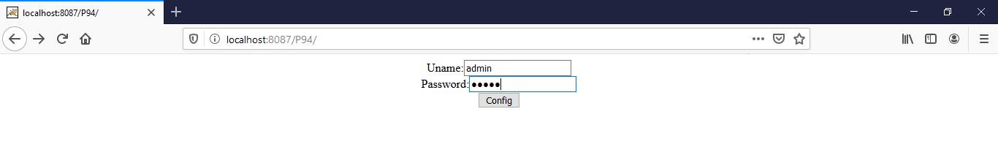

Welc1.jsp



Index.html



Error.jsp

